**ENVIRONMENTAL SCIENCE SYLLABUS**

**Cross Creek High School**

Instructor: Mr. Cornell D. Grate

Room Number: 507

Email: GrateCo@boe.richmond.k12.ga.us

Phone: 706-426-1628 (text preferred)Remind Code: kefa36

**Students, Parents, and Guardians,**

Welcome to Environmental Science at Cross Creek High School. I am very excited to engage you in the many topics concerning our environment. During this course, students will focus on human population growth, natural resources, and ecosystem dynamics. The aim of this course is to increase students’ knowledge of the environmental challenges of today, while continuing to cultivate scientific critical thinking skills. I believe your experience in environmental science will be one to remember— the labs are engaging, and the content is a great seg-way into upper level scientific thinking. Plan to actively participate in class, complete all assignments thoughtfully and on time, and to study regularly outside of class.

**Materials Required Daily:**

1) Laptop (One to One)

2) Personal

3) Loose leaf paper and binder

4) Pen (blue or black ink only) or Pencil

**Course Content Standards**

**STUDENTS WILL…**

**SEV1.** Obtain, evaluate, and communicate information to investigate the flow of energy

and cycling of matter within an ecosystem.

**SEV2**. Obtain, evaluate, and communicate information to construct explanations of

stability and change in Earth’s ecosystems.

**SEV3.** Obtain, evaluate, and communicate information to evaluate types, availability, allocation, and sustainability of energy resources.

**SEV4.** Obtain, evaluate, and communicate information to analyze human impact on natural resources.

**SEV5.** Obtain, evaluate, and communicate information about the effects of human population growth on global ecosystems.

**Grading System:**

Student grades will be recorded in the district mandated on-line portal, Infinite Campus.

**Your grade will be determined as followed:**

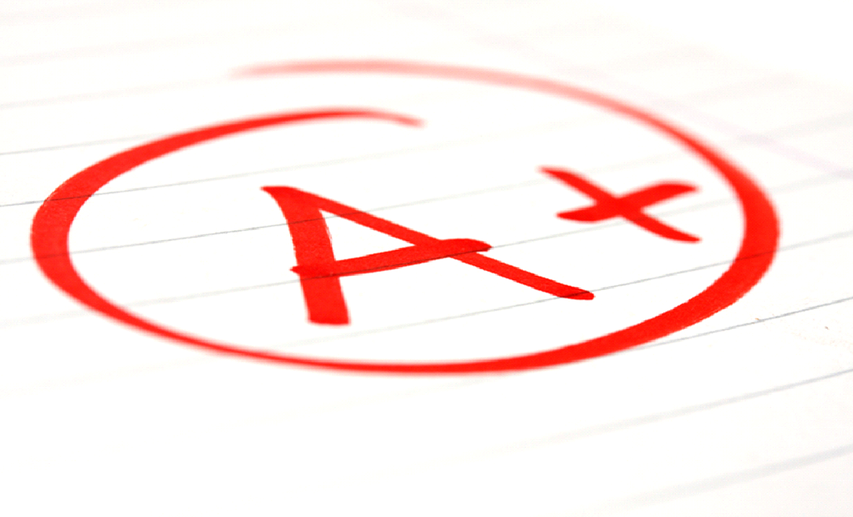

**Minor Assignments 60%**

i.e. Classwork, homework. labs, and quizzes

**Major Assignments 40%**

i.e. Tests and/or unit projects, cumulative

**CLASSROOM CONDUCT:**

It is necessary for all students to present themselves in a mature and appropriate manner that creates the best learning environment for everybody. Students must maintain respect for themselves, other students, the instructor, and our community at all times. Inappropriate behavior will result in the involvement of the student’s parent/ guardian and the school administration to aid in both correction and disciplinary action.

**Expectations**: All students are expected to follow the rules of the classroom. The rules are posted in the room as a gentle reminder of how you are expected to behave in the classroom. In the event that you decide not to follow the rules, corrective action will be taken.

1. Come to class ready to learn.
2. Be ready to work when the bell rings.
3. Bring all materials needed to class—Laptop, notebooks, pencils/pens, etc.
4. Actively participate in class.
5. **Refrain from** grooming in class--brushing/combing hair, lotion, nails, applying makeup, etc.
6. Food/candy/snacks/drinks of any kind are **NOT ALLOWED** in class unless allowed by the teacher
7. Be responsible for getting the work you may miss due to **excused** absences. To get this work you need to **SEE Mr. Grate.**
8. **RESPECT** others and other’s property—the school’s, student’s, and teacher’s.—**If it is not yours, please leave it alone.**
9. **Cellphones are not allowed in the classroom at all!!! Students will be asked one time to put the cellphone away. If that does not work, I will collect the cellphone and turn it into the office. The student will then be written up.**

**ATTENDANCE:**

In order to succeed in this class a student MUST be present. After returning from an absence, it is the student’s responsibility to retrieve the assignments and the notes missed when absent for any reason**. Make-up work will only be addressed during independent work time during class. Students must see Mr. Grate during tutorial hours** or by appointment to receive any assistance with make-up work. Remember: STUDENTS ARE RESPONSIBLE FOR MAKING UP ALL ASSIGNMENTS AND NOTES MISSED DUE TO AN ABSENCE FOR **ANY** REASON.

**STUDENT SUCCESS:**

I am very interested in the success of every student. If you are having trouble with a particular assignment or concept, do not hesitate to seek help from me. I am available for extra help during my planning period, or after school. Students and parents are encouraged to also use email to contact me at **GrateCo@boe.richmond.k12.ga.us**

Mr. Grate ***MAJOR COURSE GOALS AND INSTRUCTIONAL PHILOSOPHY***

This course is to facilitate completion of Georgia Standards of Excellence based classes. It is important students focus on the tasks with the intention of completing all course(s) material by the end of April. Should students move quickly through the material and finish prior to the expected completion date the possibility exists for the completion of additional courses during the semester. It is my intention to facilitate your success and will do whatever I can to help you succeed.

***Class Rules:***

***Consequences:***

1st Offense – Verbal Warning

2nd Offense – Individual student counseling

3rd Offense – Parent(s)/Guardian(s) contacted

4th Offense – Office Referral

\***I reserve the right to immediately refer students to the office for serious offenses\***

**Parent/Guardian Signature_______________________________**

**Teacher Signature______________________________________**